The Eye Name:___________________

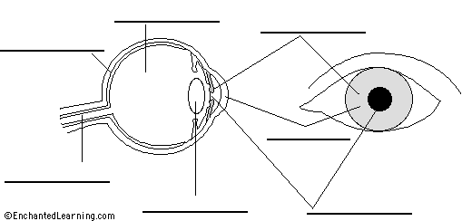
Label the following diagram:

What is the stimulus for the eye?

Through what part does it enter the eye?

What type of receptor is found in the eye?

Where are they found?

There are two different types. What are their names and what is the difference between the two?

When the light is bright what does your iris do and why?

The photoreceptors are part of the ________________ nervous system. The response of the pupil is part of the _____________________ nervous system.

